Hardware: Storage
hw_storage.php — Hardware

Storage / Secondary Memory
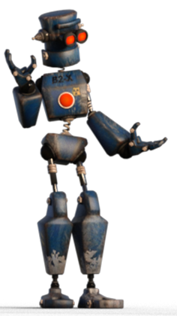

Building a long-term relationship
You want your data and your software to hang around. You want it to be there when you need it. You also want to be sure that even if you don't use a program for a year it will still be there and available when you need it.
You already know that RAM is volatile; that when you quit a program any data that has not been saved is lost and the same happens when you switch your computer off / the power goes off / a program crashes.
Storage is where data goes when you save it.
Storage is any medium that will hold digital data / files over a long period of time without being 'powered on'.
You get THREE different types of physical storage media and one virtual type of storage:
Magnetic Storage
About Hard Drives
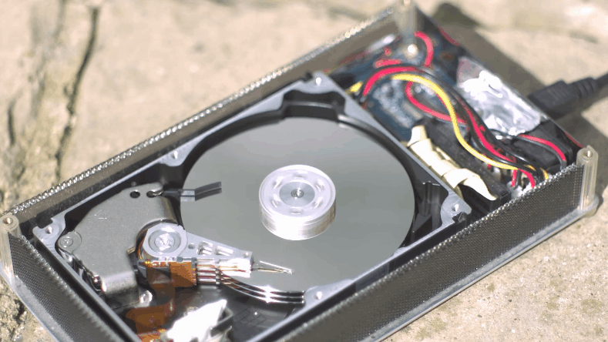
Animated gif from Giphy

Hard Drives
Hard disk drives (hdd) are mechanical devices that store data as magnetic patterns on spinning disks.
Hard drives are the
most common form of storage
available and have the advantage of being both cheap and having large capacities.
In fact,
Hard Drives offer the cheapest storage in terms of cost / Gb.
How hard drives work
The read-write head in a hdd floats above the disk surface of a thin cushion of air (thinner than a hair) - and the disk itself is spinning at speeds above 5000 rotations per minute.
As you can imagine, if any dust or debris lands on the surface of the disk then the head will smash into it like the side of a mountain.
This is why disks are made in factories cleaner than a hospital's operating theatre - and are sealed before leaving to prevent any dust getting in.
This is also why a hard drive should not be moved whilst it is working (this includes your portable hard drive and, ideally, the hard drive in your laptop).
Any unexpected bump or sudden movement to the hard drive whilst it is working can cause the head to 'crash' against the surface of the disk and damage it - possibly beyond repair!
Hard Drive Size (physical)

Hard drive sizes
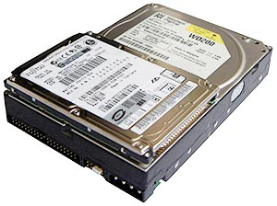
By MaxVT [CC BY-SA 3.0 or GFDL], from Wikimedia Commons
Hard drives come in two physical sizes:
3.5" desktop drives
2.5" laptop drives
3.5" hard drives tend to offer larger capacities at lower prices.
2.5" drives use less power than 3.5" drives. These drives were developed for and are used in laptops.
Both types of hard drives can be used as external hard drives.

External / Portable HDDs
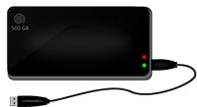
An external hard drive is a standard 3.5" or 2.5" hard drive placed into an enclosure.
Typically most people buy external drives as a package - the drive already set up in a sealed enclosure.
It is, however, possible to buy enclosures separately and install your own drive into it - this can be very useful when you want to keep a drive from an old system when buying a new computer.
The enclosure contains a controller for the hard drive and circuitry for the type of connection it supports (USB 2, USB 3, Thunderbolt or USB C).
2.5" drives are smaller, more portable and have a low enough power demand that they can get their power from the computer over the connection cable.
3.5" drives offer more capacity but need a separate power supply.
Anatomy of a HDD

Anatomy of a Hard Drive
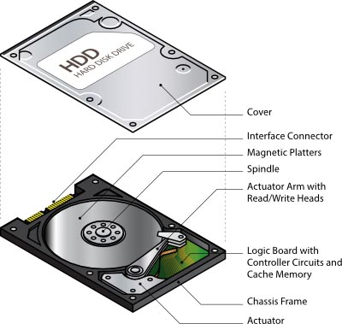
Back to the top of this Panel
Electronic (Solid Stage) Storage
Electronic storage is made up from special non-volatile electronic memory chips.
The 'solid state' in the name just means that they have no moving parts - they are made from electronic components only.
This means that electronic memory is faster than mechanical hard drives or optical drives - but, because of the way the circuitry works, it is still slower than the volatile memory used for RAM.
Being solid state also means that this type of storage can not be damaged by moving it around whilst it is working - or by dropping it. There are no moving parts!
There are three main types of electronic storage:
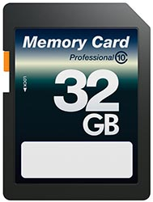
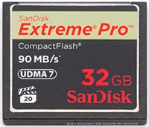
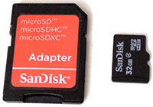

Storage for devices
Memory cards are designed to provide removable storage for devices.
You use them mainly in cameras, video cameras, GPS devices, data monitoring equipments and Android smartphones and tablets.
The three main types of memory cards are:
SD Cards:
The most common type of memory card - used with most cameras.
Micro SD Cards:
A smaller version of the SD card - used in devices where space is an issue - e.g. smartphones, tablets, drones, action cameras, etc.
Compact Flash Cards:
The largest type of memory card - used mainly in top end DSLR cameras and video cameras.

Capacities and Speeds
Capacities range from 2Gb to 1 Tb (and soon larger than that).
Speed is the rate at which the card can transfer data. High speed is essential for high end DSLRs and video cameras because they transfer many large images in short time spans.
The higher the capacity and the faster the transfer speed, the more expensive the memory card is.
So, if you see two 8 Gb cards (of any type) and one is almost double the price of the other the reason is likely to be that the more expensive card has a faster data transfer speed!

Uses of memory cards
The most common use of memory cards is as removable storage for cameras and mobile devices.
They can be used for anything you use a flash drive or a portable HDD / SSD for - after all, they are just portable storage. The biggest difference is you need a card reader to access their data!

Transferring data
The best way to connect a memory card to a laptop or desktop is to first check if the computer has a built in card reader. If so, use that.
If not, get yourself a card reader device. This connects to your computer using USB 2, USB 3 or USB C - depending on what you buy.
Buy the best connection type your computer has because the faster the connection type, the faster the data transfer and the less time you spend waiting!
Card readers usually have many slots to take multiple cards - and you can put cards into multiple slots at once (e.g. put in a SD and a Micro SD into their own slots at the same time).
The computer will then see cards inserted into the card reader as separate storage devices and you can use your file manager to copy, move, delete, etc. the files on the card.
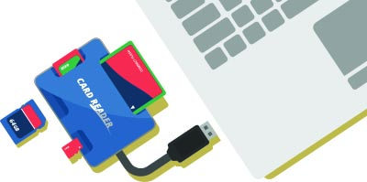
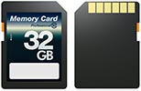
Memory Cards
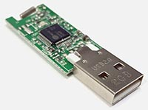
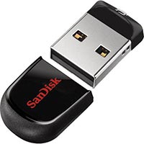

The device with many names…
Thumb drive is another one…
These storage devices are basically electronic storage chips on a circuit board with a built in USB connection.
This built in USB connection is the secret to their success. It makes them very easy to use. Being electronic, they are faster than mechanical hard drives and they are a very convenient way of carrying data around with you.
Flash drives come in many shapes and sizes - and the size is not an indicator of the capacity of the drive.
Despite their convenience, their use is decreasing because of the availability and speed of the internet which allows people to send files to each other easily and quickly.
Online storage services such as DropBox, Google Drive, OneDrive, iCloud Drive make it easy for people to save and retrieve files from the internet without having to carry around portable storage such as flash drives or portable hard drives.

Dangerous Media
This type of media is dangerous in several ways:
Vector for malware:
Flash drives are used in many different computers. If used in a computer infected with malware it is likely that the drive will become infected and then infect your computer when you use it there.
The Dropped Drive attack:
Hackers use this as a way to sneak hacking software onto a computer. Drop a flash drive in a public space (the parking lot of a target company, for example). Wait for someone to pick up the drive. The target person is inevitably curious and uses the drive on their computer. The hacker's software installs itself and creates a backdoor for the hacker to access the computer….
The Drive of Death
You can put any electronics inside a flash drive casing. Someone came up with the idea of putting capacitors in the case instead of memory chips. The capacitors draw electricity from the computer, store it and then release it back to the computer as a high voltage surge that fries the electronics and kills the computer. Another reason not to plug that random flash drive that you picked up into your computer!

Flash Drives / USB Drives / Memory Sticks
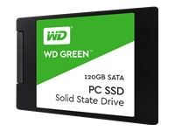
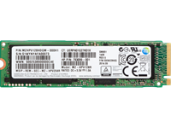
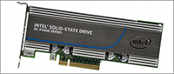

The fastest storage by far
Once you have used a computer with an SSD you never want to go back.
Any machine with a mechanical will seem like a slow, clanking, grinding dinosaur that makes you wait forever.
Yes, the difference is that great!
That said, SSDs may be fast but they are also expensive. In 2010 I bought a 1 Tb SSD and replaced my laptop's DVD drive with the SSD. That drive cost R12 000. Today that drive would cost about R3 500. a 1 Tb HDD on the other hand costs around R600 - R800.
SSDs come in many shapes and sizes.
They can be cards that plug into the PCIe slots on your motherboard (like your video card does).
These are much less common today.
They can be cards that plug into a special high speed NVMe slot on the newer motherboards.
This is the fastest (and most expensive) type of SSD.
They can look like normal 2.5" had drives and connect to the same SATA connectors used by hard drives in your computer. This type of SSD can also fit into an external hard drive enclosure.
These are cheaper and slower than NVME SSDs.
The cheapest versions of these drives use quad layer SSD memory cells - and are not much faster than a magnetic hard drives.
Like with memory cards, SSDs have different speed ratings and if you look at two SSDs with the same capacity but one is much more expensive you can be pretty sure that the more expensive one has the higher speed rating.

Best value for your SSD bucks…
To keep costs down but still benefit from a speed increase many computers are built with two drives:
A smaller SSD (128Gb, 256Gb or 512Gb) which is used as your boot drive, contains your OS and your applications and which is used as the location for your swap drive.
A second, larger HDD (1 Tb or more) which is used for your data.
By using the SSD for your applications and OS you load software faster and get some benefit from the faster storage.
If you use lots of large data files though, it is probably a better idea to go SSD all the way if you can afford it!

Anatomy of an SSD
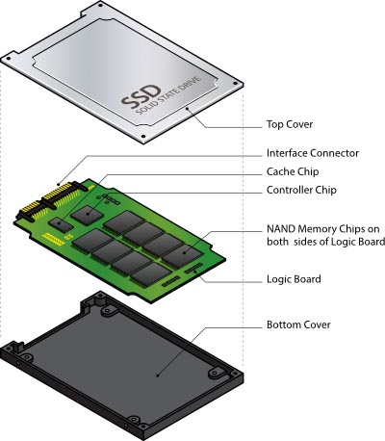
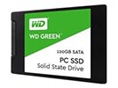
SSDs
A hybrid drive looks like a normal hard drive.
Inside the case though there is a small SSD and a spinning mechanical, magnetic hard drive.
The SSD is used to cache data from the hard drive (caching is discussed in Grd 11 & 12).
The result is that the hybrid drive is faster than a normal hard drive, but slower than an SSD.
Much more scarce today as SSDs have become more affordable.

Anatomy of a Hybrid Drive
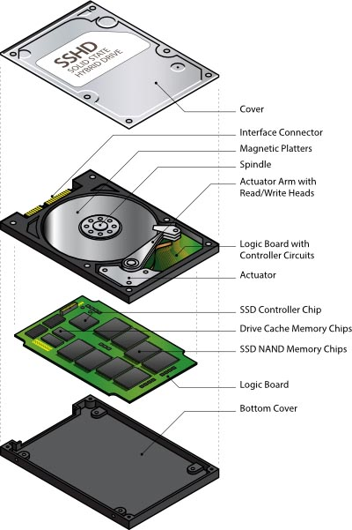
Back to the top of this Panel
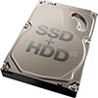
Hybrid Drives
Optical Storage
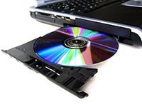
Optical drives are mechanical devices that store data using the optical properties of light.
Optical storage is still used as a distribution medium for music (CDs), movies / TV series (DVD / Blu Ray) and Games (DVD) but is seldom used with computers any more.
In fact, it is rare to see a new desktop or laptop that has got an optical (DVD drive).
This is because optical storage is relatively slow, bulky, low capacity and relatively unreliable compared to flash drives and portable hard drives / SSDs.
Optical media was used as a distribution media for software. You would buy the software in a box in a store, take the box home, take the CD / DVD out of the box, put the disc in your computer's optical drive and then install the software.
Today internet connectivity and bandwidth is high enough that this seldom happens anymore - people simply buy software online, download it and install it from the downloaded file.
You also got writeable versions of optical media that people used to carry data around with them and for making backups.
This has been replaced by online data transfer and the use of much faster, larger capacity and more reliable flash drives or portable HDDs / SSDs.
What to do if you have an optical disc but no drive?
If the disc contains software the easiest is to look for the software online and download it from there.
If the disc contains data or a backup then you can either
buy an external (USB) optical drive and use that (they are not expensive) or
find someone with an optical drive and copy the data off the disc onto a flash drive / portable HDD / SSD.
NB: This may be illegal according to the EULA of the software.
If optical drives are so obsolete why learn about them?
For exactly the type of scenario described above…

Optical disc capacities
CD: 600 - 800 Mb
DVD: 4.7 - 9.4 Gb
Blu Ray: 25 - 50 Gb
Back to the top of this Panel
Cloud Storage
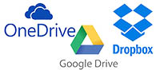
Cloud storage is nothing more complicated than storage connected to servers on the internet. The service provider usually has petabytes of storage connected to and managed by thousands of servers.
The service providers generally give you a small amount of storage space for free in the hope that the convenience of the service will convince you to subscribe to be able to access a larger amount of storage.
Cloud storage can be described as virtual storage because it is storage that you can not touch - it is storage that may be split across multiple computers scattered around the world.
Cloud storage providers also create apps for different OSs and devices so that you can access your storage space from anywhere - including through a web browser.
Examples of cloud storage services include DropBox, Google Drive, OneDrive and iCloud Drive.
These services make it easy for people to save and retrieve files from the internet without having to carry around portable storage such as flash drives or portable hard drives.

Syncing
Cloud storage services are also the way to keep your devices in Sync (i.e. have the same versions of files on your devices at the same time).
The idea is that you set up a folder on your local storage and link that to the cloud storage service. You then save all your files in this folder on your own storage (and in sub folders).
The app from the cloud service will check this folder for any changes (new files, edits, deletions, etc.) and automatically copy these changes to the cloud storage service.
Any other desktop or laptop that has the app installed and is logged in to your account will check the cloud folder for changes.
Any changes (new files, updated files, deletions, etc.) will be copied to that computer's hard drive.
Any changes made on the other computer will be copied to the cloud and back to your computer.
That's how you always have the same versions of files available no matter where you are.
Mobile devices usually have apps that allow you to access the cloud storage but rarely sync the cloud files to the device - simply because the device often does not have enough storage!

Why is this better than using portable storage?
It is simple really. When you have files on local storage in your computer - and on portable storage such as a flash drive or external hard drive, it is very difficult to tell easily which one is the most recent version of the file.
People often lost data by accidentally overwriting the new version with the old version.
It is also very easy to work and forget to copy the new version of the file back to the portable storage when you are done - meaning that you can get to school and only have the old, incomplete version of your project on your portable storage whilst the finished version is at home on your computer… (NB: your teacher will only accept this excuse once - more than once and they'll guess that there is no completed version, you just didn't do the work!).
Back to the top of this Panel

Video Links - Storage
We have selected and curated a set of videos on YouTube related to your course.
These videos are not created or owned by us.
They may display advertising and in some cases may contain limited amounts of swearing.

Notes for this Module
What to look out for and do in this module...

FAQs for this module
Questions on Types of Networks and their answers...

Network Types FAQ
View the questions or type in the term you are looking for below…
No results were found

What is the best storage to use?
SSD.
The speed difference is worth every cent!

Should I get / do I need an optical drive?
Not unless you want to play DVDs or music CDs.
Optical storage is not used much anymore.

Hard drives last forever - as long as they are trade right - isn't that so?
No.
Hard drives are very reliable and last a long time - but they do fail eventually.
Always make a backup of your data as you never know hen that failure might happen.
Extrenal drives or hard drives used for backup and then removed from the computer and not connected to power can lose their data as the magnetic patterns stored on them slowly get demagnetised.

Do SSDs have a shorter lifespan than hard drives?
Yes - though this is less true of newer SSDs and the technology is improving all the time.
Due to the nature of the electronics on an SSD it can only be written a certain number of times before the circuit can no longer store data.
Don't panic though!
This lifespan is longer than the average lifetime of a computer's use before it needs to be upgraded.

What is cloud storage?
Storage on someone else's computer!
Cloud storage is simply uploading files to be saved on a storage device connected to a computer that is connected to the internet.
You pay for the amount of storage space reserved for your use.
Using cloud storage uses part of your data 'cap'.

